

SHOPPING CART

Database Design



Jacob kurien

Roll no:19

s9 Int mca

**Shopping Cart**

**DATABASE DESIGN**

**User management**

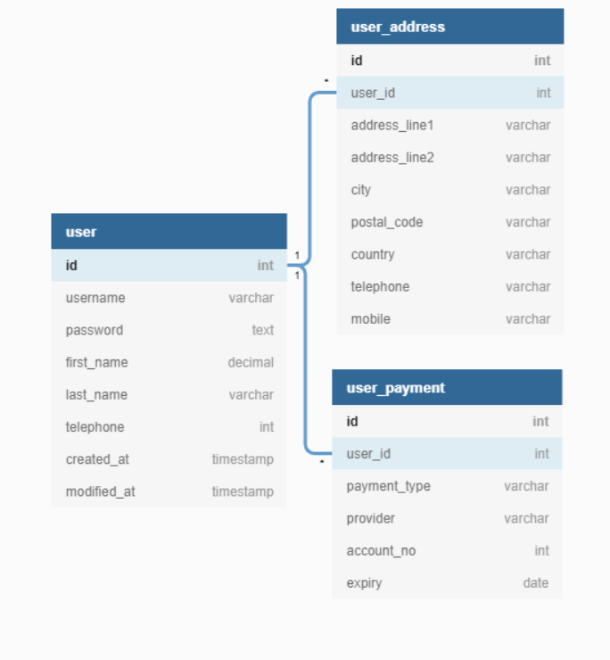

**Product management**

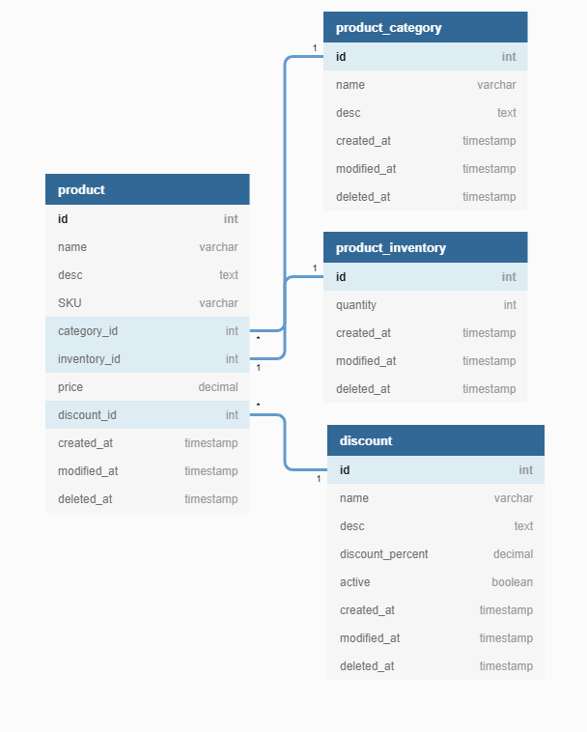

**Shopping process**

